^{Chapter}

High School Scholarship for Summer Study of German ($300.00)

The Maryland-DC Metro Chapter of the American Association of Teachers of German is committed to promoting the study of the German language and culture. The chapter has created this scholarship to assist high school students from the chapter in the pursuit of additional study and / or immersion in German during the summer.

The program that the student participants in must have a substantial study component in the German language. Some eligible programs include internships in Germany, Goethe Institute courses, or immersion programs abroad that include instruction.

Travel programs in English to German-speaking countries are not eligible.

Eligibility Requirements:

- High school student currently enrolled in a German at a high school of our chapter.
- German teacher must be current member of the AATG, listed with the Maryland/DC Metro Chapter.
- Student must have a 3.0 GPA in German courses, verified by his or her German instructor.

Application:

- Application Form (see below).
- One-page, typed statement of purpose explaining why the student wants to do a summer study program in German. This must include the actual program student has applied to, cost of program, program dates. Essay should also address reasons why the student has applied for financial assistance in the form of this scholarship.
- German teacher recommendation.

Application is to be submitted to the current Chapter President to arrive by the listed deadline of March 1, 2019. The funds ($300.00) will be disbursed prior to the Summer Study program.

Follow Up
Student must submit a brief report of experiences with documentation of the program being successfully completed.

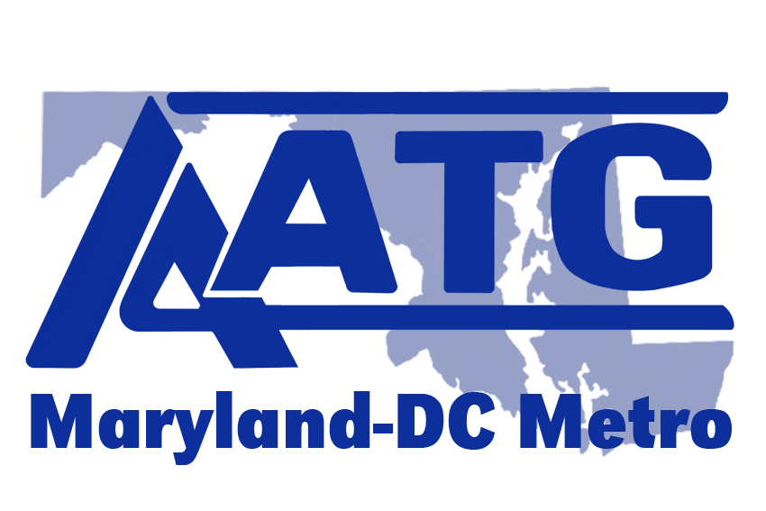
^{Chapter}

APPLICATION FOR
High School Student Scholarship for Summer Study of German

Name: ____________________________________________________________

Today’s Date: ______________________________________________________

Address: __________________________________________________________

__________________________________________________________________

Phone: ____________________________ Email: __________________________

Current Year in School: _________________________________________

Name of High School: ________________________________________________

Address: ___________________________________________________________

___________________________________________________________________

Name and Email of German Teacher:

___________________________________________________________________
must be a current member of AATG, listed with Maryland-DC Metro Chapter

Name, Location & Dates of Summer Study Program. Please also provide the website address for the program:
____________________________________________________________________
____________________________________________________________________
____________________________________________________________________
Checklist for Application:

_______ Recommendation requested on __________________________________ (Date)

_______ I have attached a 1 page personal essay stating reasons for studying German, the details of the Summer Study program I have applied for and reasons for need of scholarship.

Signature___________________________________________________________________

Send this and all application materials by e-mail to the chapter president: mgrah4@verizon.net

